Executive Summary
- Preliminary work.
- One batch of assay results outstanding
- Comparisons were done between the re-assays completed at ALS in Romania and the assay results in the Global Gold (GG) database.
- The mutli-element correlations and dispersions in 3D are being undertaken and we will provide a more thorough appraisal next week. There appear to be good dispersions for As, Pb, Zn which will assist in our understanding.
Pulp Re-Samples
- 1013 assays of pulps have been completed.
- A comparison was done between the results obtained for the re-sampled pulps and the Global Gold results for Au and Ag – total of 551 pairs (results weren’t in the database for all of the Global Gold assays)
- Correlations between the GG results and the ALS results was very poor (effectively no correlation). Average Au grade for resamples (551 samples) was 0.09 g/t compared to 1.58 g/t for the GG pulps
- Gold assay results were low – 6 pulps (from 1013) had Au values >= 1 g/t and 10 had Au values >= 0.5 g/t
- Silver assays low – 11 pulps (from 1013) had Ag values >= 5 g/t
Core Re-Samples
- 864 core re-assays have been completed (1 batch outstanding)
- Results were compared for the resampled pulps and core assays. 507 pairs were compared, correlation poor, but random spread.
- Gold assay results were low – 4 core samples (from 864) had Au values >= 1 g/t and 10 had Au values >= 0.5 g/t
- Silver assays low – 7 core samples (from 864) had Ag values >= 5 g/t

Correlation between Gold samples (Orig assays and Re-assayed pulps)
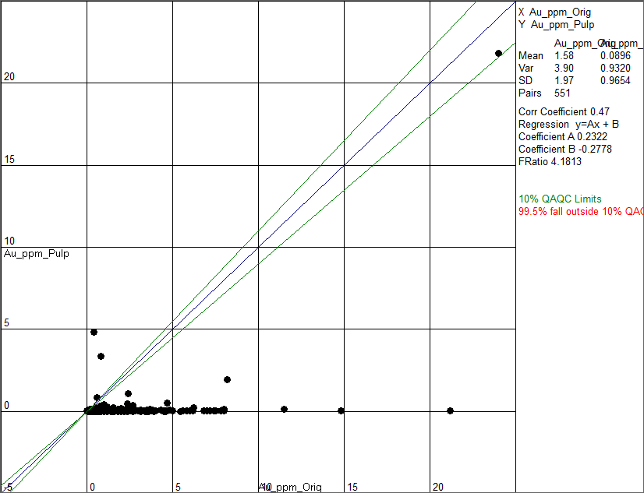

- Pulp re-samples were compared against the Global Gold assay vales for gold
- The blue diagonal line is where the pairs should plot and the green lines are the 10% limits from the expected. (Note that coarse gold generally exhibits a poor correlation but should plot in a ‘cloud’ both side of the blue line).
- 551 pairs
- 99.5% fall outside 10% limits (i.e. no correlation) and concentrated below the expected i.e. apparent bias.

Correlation between Silver samples (Orig assays and Re-assayed pulps)
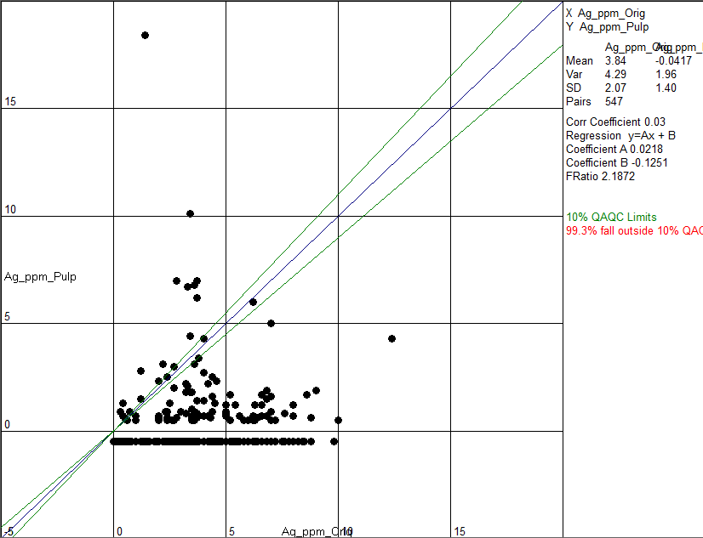
- Pulp re-samples were compared against the Global Gold assay vales for silver
- The blue diagonal line is where the pairs should plot and the green lines are the 10% limits from the expected. (Note that coarse silver generally exhibits a poor correlation but should plot in a ‘cloud’ both side of the blue line).
- 547 pairs (upper limit of 20 g/t Ag used)
- 99.3% fall outside 10% limits (i.e. no correlation)
- Spread is more random than for gold although there does appear to be a higher bias to the Orig results

Correlation between Gold samples (Re-assayed Core and Re-assayed pulps)
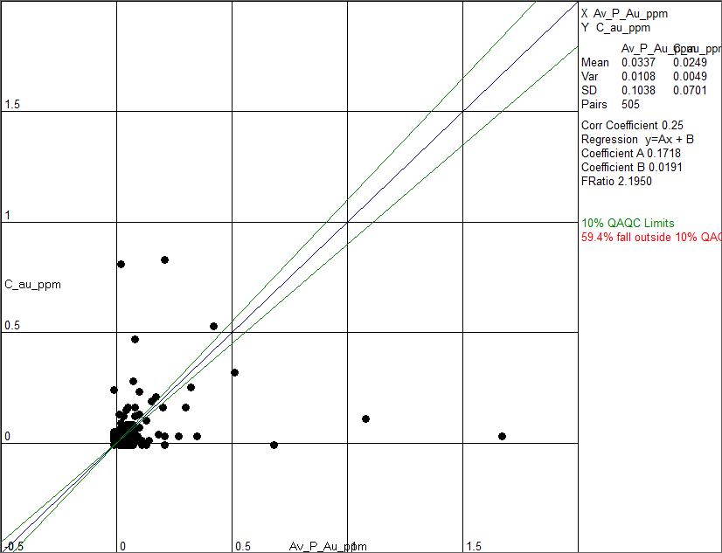
- Comparison between re-assayed pulps (weighted average) and core.
- 505 pairs (upper limit of 2 g/t used)
- 59.4% fall outside 10% limits (i.e. poor correlation but expected for coarse gold). Random spread, no apparent significant bias.

